

**FY15**

**Draft Operating Plan**

**and**

**Budget**

**TABLE OF CONTENTS**

*Introduction*

# 1. FY15 Highlights

1.1. Revenues………………………………………………………………….….7

1.2. Operating Expenses………………………………………………………...9

1.3. Headcount 3 Year Overview………………………………………………11

1.4. Statement of Activities……………………………………………………..12

1.5. Capital Expenditures…………………………………………………..…...13

1.6. Resource Utilization ICANN Ops……………………………………….…14

1.7. Risks and Opportunities…………………………………………………….15

# 2. FY15 Operating plan

Management System ……………………………………………………….…….16

Strategic Objectives and Goals……………………………………………...…...17

Objective 1: Affirmation of Purpose..……………………………………….…....18

Objective 2: Operational Excellence..…………………………………….……...30

Objective 3: Internationalization…....…………………………………….……....45

Objective 4: Multistakeholder Model Evolution…………………………….…....54

# 3. New gTLD Program – Multi-year View

3.1. New gTLD Financial Summary……………………………………….……..63

3.2. New gTLD Multi-year View…………………………………………….….....65

3.3. New gTLD Program – Revenue Variance Analysis………………….…...66

3.4. New gTLD Program – Expense Variance Analysis………………….…....67

*Appendix*

Introduction

This document sets forth ICANN’s draft annual Operating Plan and Budget for FY15 (from 1 July 2014 to 30 June 2015). This draft will be submitted to public comment and may be modified as a result. The public comments and potential changes to this draft will be communicated to the Board Finance Committee and the Board along with the final Budget (including potential changes) submitted for Board approval.

Community feedback and input are a critical component of the accountability and transparency of the Multistakeholder model. The public comment process is the opportunity to provide feedback on the planning process and the content of this document, with specific and constructive input.

As a result of the previously received feedback, the Operating Plan and Budget includes:

* An introduction describing the highlights of FY15
* An overview of the budgeted resources and expenses, including comments on year-on-year variances by category and by function.
* A description of the activities of the organization planned for in FY15 for each portfolio. A list of selected projects included in each portfolio in FY15. Their associated budget amounts can be found in Appendix A.2

The amount of information provided is significant and is the result of a detailed planning by the organization during the weeks preceding the publication of this draft. This detailed amount of information requires on-going review, and ICANN expects that corrections or adjustments are identified routinely and could be reflected in the final version of this document.

The public comment process should also provide an opportunity to any reader to help this validation process by signaling to ICANN staff apparent or possible inconsistencies to ICANN staff. We appreciate the collective work towards permanent improvement of the quality of the information that ICANN publishes. Please provide feedback in the public comment response section of ICANN.org.

Beginning with the FY16 annual planning process, the Five-Year Strategic Plan will provide input into the annual planning process.  The graphic shows the expected annual planning cycle for FY16-20, at a high level.

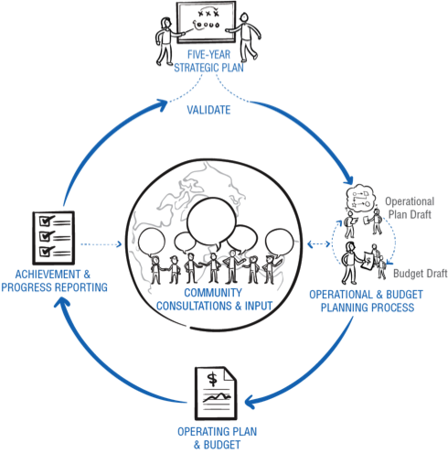

1. FY15 Highlights

ICANN is entering FY15 with as much focus on its accountability and transparency mechanisms as ever. With the significant amount of work that the organization has been facing in most areas, it has grown significantly over the past 2 years.

As a result, with the objective of maximizing efficiency and continuously improving operational performance during FY15, management will focus the organization on fully integrating the resources on-boarded by the end of June 2014, and stabilize the organization during FY15 and maximize efficiency, with limited growth in selective areas. Additionally, management will ensure that specific and targeted resource investments support the following activities:

* Manage the USG transition process
* Develop the gTLD service platform to accommodate the growing volume of activity
* Launch multi-year build-out of enterprise system architecture (IT front end and back end)
* Optimize the Contractual Compliance capabilities.

**1.1. Revenues**

* + 1. Revenue Overview



1.1.2. Revenue assumptions

* Historical gTLD revenue stream is consistent with current growth trend (+2% of registrations), leading to a 1% growth of revenues.
* New registries assumptions:
  + - In the root by end of June 2014: 400
    - In the root by end of June 2015: 1200
    - 33 million registrations in FY15.
* Sponsorships/contributions
  + - ccTLD: FY14 includes some FY13 contributions collected in FY14. Excluding those, the ccTLD contributions grow following the recent ccNSO contribution guidelines.
    - Meetings sponsorship lower due to 3 meetings in FY15 vs 4 meetings in FY14.
* New gTLD revenue continue to decrease as the evaluation work and spend decreases year on year.

**1.2. Operating Expenses**

1.2.1. ICANN Operations (excludes New gTLD program)



See comments on each variance item on next page.

The operating expenses budget for ICANN Ops (excludes New gTLD) is $117M. This represents a $25M increase from the FY14 level of $93.

* Exceptional items - FY14 Strategy Panels and ATLAS II costs not included in FY15
* 1 Less ICANN meeting (3 in FY15 vs. 4 in FY14)
* Full year impact of FY14 hiring - Increase in personnel costs due to 120 employees hired in FY14 working a full year in FY15 vs. a partial year in FY14, plus increase/promotion assumption.
* Priority areas - GDD service platform, Enterprise system architecture, and Optimizing Contractual Compliance
* Other - Increase in depreciation due to capital investments (Salesforce, Digital Platform, website, etc.), decreased allocations to the New gTLD Program and all other variances.
* Contingency - Higher Contingency as a percentage of operating expenses
* USG Transition – transition of the IANA stewardship role of the U.S. Government.

**1.3. Headcount - 3 Year Overview**

The headcount of the organization is expected to grow at a slower pace towards a normalized level. The headcount growth after June 2014 is concentrated in the areas listed in the FY15 Highlights section (page 6), while other areas have marginal hirings.

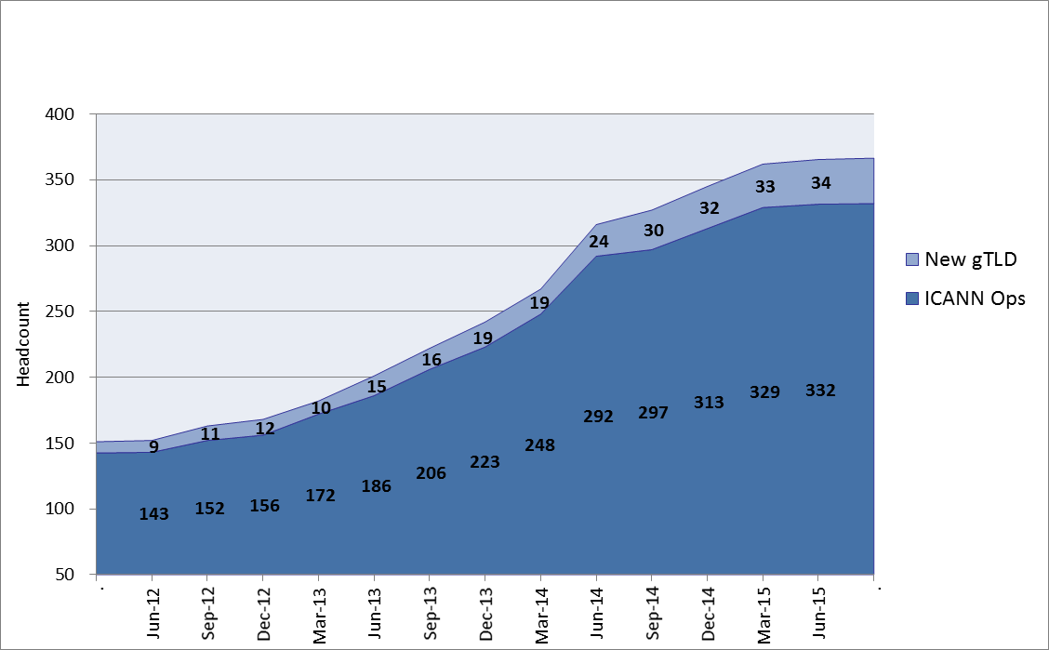

**1.4. Statement of Activities**



1. Impact of 120 employees hired in FY14 working a full year in FY15 vs. a partial year in FY14, and FY15 hires
2. 3 ICANN meetings in FY15 vs. 4 in FY14 and no ATLAS II in FY15 partially offset by additional travel for new hires
3. No Strategy Panels in FY15 and reduced consulting costs due to more internal resources
4. Increase in facilities costs, primarily due to headcount increase and hub offices
5. Impact of FY14 capital investments (Salesforce.com, Digital Platform, website, etc.)
6. The FY14 contingency of $3.7M has been used on travel & meetings, professional services and administration and the costs appear in those respective lines

**1.5. Capital Expenditures**



**1.6. Resource Utilization - ICANN Ops**



**1.7. Risks and Opportunities to the FY15 Budget**

|  |  |
| --- | --- |
|  | High/Medium/Low Likelihood |
| **Risks** |  |
| USG Transition: requires significant unbudgeted actions | Med |
| Revenue shortfall due to:  slower ramp up of registries  lower number of transactions per registry | High  Med |
| Overspend: Functional budgets have little to no contingency | Med |
|  |  |
| **Opportunities** |  |
| USG Transition: requires less work / costs less | Low |
| Revenue upside due to:  Faster ramp up of registries  Higher number of transactions per registry | Low  Low |
| Lower spend based on delayed activities | Low |
| Effectiveness of costs saving actions | Med |

Risk: defined as the possibility of a lower revenue or higher cost / Opportunity is the opposite.

2. FY15 Operating plan

**Management System**

Our framework for the Operating and Budget plan is based on the below structure. This allows to map all activities and resources back to our four main Objectives. The Operating Plan information in this document is organization on the basis of this structure.

* **4 Objectives-** these are core areas for us to deliver on, and remain unchanged at this level from FY14.
  + **16 Goals-** typically owned at the Global Leader level, the 16 goals also have defined Key Success Factors to help clarify what ‘success’ looks like.
    - **50 Portfolios**- within each goal is a set of Portfolios. Portfolios also have defined Key Success Factors (KSFs) and we actively measure Key Performance Indicators (KPIs) on a regular basis (depending on what is being measured).
      * **300 Projects (approximately)-** Projects should be viewed as somewhat fluid as this is very much an operational level for ICANN staff. The Budget gets assigned at a Project level. Selected Projects can be found within this document under the section for the Portfolio to which it has been assigned. Their associated budget amounts can be found in Appendix A.2.



**1. OBJECTIVE: AFFIRMATION OF PURPOSE**

**1.1 GOAL: DELIVER ON CORE INTERNET FUNCTIONS** by delivery of round-the-clock key (and usually technical) services essential to the functioning of the Internet.



1.1.1 The WHOIS core function/service & improvements Portfolio includes projects relating to the implementation of the Board-approved recommendations resulting from the first WHOIS Review called for under the Affirmation of Commitments (AoC).

1.1.2 IANA Operations Portfolio includes projects that will: (a) measuring and reporting the continuous improvement in delivery of the IANA functions; (b) enhancing the Root Zone Management (RZM) system and other tools used to deliver the IANA functions; and (c) continuing several DNSSEC initiatives to maintain the security and stability of the root.

1.1.3 Internationalized Domain Names (IDNs) Portfolio. This work enables development of variant management procedures for the root zone. The set of activities incorporates a high level of community involvement so that the results are informed by expertise from all regions. Study and consultation are designed to inform processes for creating a label generation rule set for the root zone, and help identify measures required to support a good user experience in the implementation of IDN variant TLDs.

Highlighted Projects:



1.1.4 The Root System Operations Portfolio related projects are aimed at: (a) increasing heterogeneity, scalability and resiliency in operation of the L-root server; (b) measuring, reporting and analyzing performance of L-root; and (c) planning and executing a table-top exercise with the Root Zone Partners (ICANN, NTIA and Verisign).

Highlighted Projects:



1.1.5 The Security Stability & Resiliency (SSR) of Identifier System Portfolio continues to focus on observing, assessing and influencing the SSR of the Internet’s Identifier systems in close collaboration with other ICANN departments and the community. This will be achieved through a range of activities including risk awareness and preparedness, measurement and analysis of identifier system behaviors or performance, and cooperative outreach that emphasizes coordination, capability building, and knowledge transfer.

Supplying Ongoing Expertise: During FY15 the department will coordinate closely with the Global Stakeholder Engagement GSE team to contribute SSR subject matter expertise in ICANN’s engagements with private sector, civil society, governments, and others, and to participate as delegates to OECD Working Party on Information Security and Privacy and Security Expert Groups, NGO representatives on Commonwealth Cybercrime Initiative committees, or similar roles that the GSE team recommends.

Highlighted Projects:



1.1.6 Corporate Security - DNS Center of Excellence. During FY15, SSR staff will provide expertise to the DNS Security Center of Excellence (India) as needed in order to enable the growth of the centers’ capabilities and eventually see return to the community in the form of research output and capacity building in the region. This will focus on “train the trainer” efforts, and aiding in defining research areas.

Capability Building. This area will build on the successful knowledge transfer programs that ICANN has developed and delivered to ccTLD operators, law enforcement, and staff, with the goal of identifying programs that will not only be delivered to current audiences but also used to reach out to new audiences.

During FY15, ICANN will take a complete inventory of existing capability building program content and methods of delivery, define with the community a desired/target inventory, perform a gap analysis, and develop missing elements to these programs.

In parallel, ICANN will classify programs as “canned” or “custom.” ICANN will apply time, talent, and technology to render those programs identified as “canned” into forms that can be delivered digitally. The programs of this kind will generally teach fundamentals. The “custom” classification includes programs that involve transfers of “trade craft” which require more in person interaction.

**1.2 GOAL: ACT AS STEWARD OF THE PUBLIC INTEREST -** Emphasis on and demonstration of serving in the global public interest / public benefit in all aspects of the work of ICANN. As seen by clarifying and promoting an understanding of the public Interest, and developing and assessing "Guidance" for ICANN's stewardship.



1.2.1 The “Affirmation of Commitments (AoC) Reviews” Portfolio will include projects relating to: (a) conducting 3 Affirmation of Commitments reviews in conformance with the timelines in the Affirmation; (b) implementation of ATRT2 recommendations; (c) the implementation of Accountability Metrics and Benchmarks; (d) implementation of Board-adopted recommendations stemming from previous AoC reviews (i.e., Accountability and Transparency, SSR, and WHOIS); (e) development of a new model for Directory Services (WHOIS Expert Group); and (f) facilitation of the work of the Implementation Advisory Group for Competition, Consumer Trust and Consumer Choice in preparation for the future review mandated by the AoC.

Highlighted Projects:



1.2.2 The Define, build a guidance framework & identify programs to meet public interest” Portfolio will include projects supporting the: (a) creation of a framework for ICANN's bodies to assist them in assessing how their actions can be better aligned with the public interest; and (b) assessment of the public interest framework and its implementation; and (c) evaluation of recommendations from the Public Responsibility Panel.

**1.3 GOAL: ENGAGE IN THE INTERNET GOVERNANCE ECOSYSTEM** by participating in, and teaming and actively engaging with, the full spectrum of organizations involved in Internet Governance (IG). This will involve: (a) increasing the number of organizations with public recognition of roles and responsibilities in the IG ecosystem; (b) identifying, tracking and communicating to stakeholders relevant outputs of the five strategy panels; (c) contributing to ICANN's efforts on the evolution of the IG ecosystem and to the relevant areas of IG as undertaken by other organizations; and (d) identifying and operationalizing key areas relevant to ICANN's evolution in the IG ecosystem, including the Affirmation of Commitments.



1.3.1 The “Coordination of ICANN participation in Internet Governance” Portfolio will include projects, that will focus on : (a) increasing coordination and collaboration among Internet technical community and I* organization leaders; (b) supporting 1Net; (c) defining and coordinating ICANN's role in IG ecosystem and participation in the Internet Governance Forum (IGF) and regional IGF events; (d) implementing strategic panel outputs; and (e) increasing or change in engagement level with defined targets.

Highlighted Projects:



**1.4 GOAL: DEEPEN PARTNERSHIPS WITH INTERNET ORGANIZATIONS** by participating, teaming and actively engaging, usually publicly, with I* organizations.



1.4.1 The “Build stronger partnerships with Internet organizations and initiatives” Portfolio will consist of projects, such as: (a) establishing clarity on roles and responsibilities of Internet Organizations within a framework; (b) establishing a framework(s) for partnership; and (c) engaging regularly with Internet organizations on initiatives to strengthen ongoing relations and partnerships.

Highlighted Projects:



**2.0 OBJECTIVE: OPERATIONAL EXCELLENCE**

**2.1 GOAL: INSTITUTIONALIZE MANAGEMENT DISCIPLINES** by developing and adopting management systems, processes and standards to increase management insight, control and efficiency. This will involve: (a) achieving management understanding and utilization of standardized systems and processes; (b) continued development and enhancement of the mechanisms that enable management to make timely and effective decisions; and (c) timely implementation/tracking of AoC recommendations, as directed by the Board.



2.1.1 The Management Systems Mapping Portfolio will include projects that will support the following activities: (1) standardizing and aligning management systems within ICANN to ensure linkage, consistency, and with effective use of resources; (2) creating and automating Executive Dashboard for business intelligence, organization visibility and risk mitigation; (3) improving performance evaluation system to motivate and drive excellence in management and staff performance; and (4) ensuring continued adoption and increased value-add of Portfolio management system.

2.1.2 The Strategic Initiatives Portfolio will include projects that will focus on: (a) supporting cross-Community efforts of the Strategy Panels in regards to ICANN's role in the future of internet governance; (b) facilitating the work of high-level panel (HLP) in promoting the Multistakeholder model; (c) advancing the support of the Multistakeholder model with tools, community discussion and reporting of activities and progress.

Highlighted Projects:



2.1.3 The AOC Reviews Implementation Portfolio will include projects that support, and are associated with, implementation of the Board-approved recommendations from several review teams, in various stages of completion – ATRT2, SSR RT and WHOIS RT.

2.1.4 The “Business Excellence via European Foundation for Quality Management (EFQM) Standards” Portfolio will consist of projects to support: (a) executing on ICANN Business Excellence roadmap, including the refinement and documentation of operational processes and implementation of improvements; (b) completing the initial EFQM internal assessment on Operations; and (c) continuing to maintain the IANA EFQM processes.

**2.2 GOAL: MATURE ORGANIZATIONAL SUPPORT FUNCTIONS** by supporting functions so that they are operating in a standardized and harmonized manner, thereby increasing efficiency and the quality of output. This involves ensuring standard systems and processes that work across the organization in an integrated fashion and that quality services are delivered timely and effectively.





2.2.1 The “Support Enterprise Wide Systems" Portfolio will consist of projects to support: (a) implementing organizational system and process improvements to achieve and maintain service availability and delivery in accordance with published SLA's; (b) assessing support function system improvement requirements, determining restructuring roadmap, and implementing an initial phase of refinements; and (c) developing and implementing infrastructure and applications to ensure proper system support for new gTLD growth & Community involvement.

Highlighted Projects:



2.2.2 DNS Internal Infrastructure deals with the ICANN’s server infrastructure that supports the DNS Root Servers (L-root) and the number-to-name mapping in IPv4 and IPv6.

2.2.3 The Contractual Compliance Functions Portfolio includes: (a) the rollout and completion of the Contractual Compliance Year-3 Audit Program; (b) stabilization and evolution of the monitoring and enforcement of the agreements; (c) cross-functional training for scalability; (d) contributions to the policy support and working group effort; (e) the rollout and reporting on the new Registry Agreement Audit; and (f) migration of the compliance complaint management tool to the ICANN enterprise solution.

Highlighted Projects:



2.2.4 The Meetings Operations Portfolio will include projects to support ICANN’s to work collaboratively with its Multistakeholder community to strengthen regional and global engagement in the ICANN processes. ICANN Public Meetings facilitate both face-to-face and remote interaction among a growing number of international participants.

Activities in support of the ICANN Public Meetings are:

* Conduct three ICANN Public Meetings in this fiscal year. Activities include site selection, contract negotiations, logistics planning and execution, development of the technical infrastructure, and sponsorship development and support.
* Focus on increasing the professionalism of ICANN Public Meetings through improved execution of audio-visual technology, simultaneous interpretation and scribing services, and remote connectivity.

Highlighted Projects:



2.2.5 The Legal internal support and Support ICANN Board Portfolio will include, among others, projects that will focus on: (a) maintaining a variety of tools to support the work of the Board, including a Board portal; (b) providing administrative and travel support for all Board members for three workshops, three ICANN Public Meetings, and as required for regularly scheduled Board meetings or appearances; (c) providing administrative support to all Board committees; (d) effectively manage the Board calendar, including regular tracking of the work of the full Board and Board committees; (e) supporting the Board of Directors in its work to assess Board skills and provide a variety of training options for directors; and (f) supporting the implementation of ATRT2 recommendations approved by the Board.



2.2.6 The Support Function Operations Portfolio will include projects that will help: (a) advance support functions globally with proper controls and effective processes; (b) adopt and implement HR Business Partner approach to partner with management in organization development and change management; and continue to develop and implement HR development programs to ensure hiring/retaining the best, motivate and advance staff, and to ensure succession; (c) advance financial reporting, budget and forecast processes, accounting service efficiencies, procurement controls, and cost management initiatives to ensure the effective use of organization assets while maintaining/increasing quality; (d) implement the meeting strategy as approved and adopted by the Community; and (e) review and model HR practice and compliance to best practices, develop improvement plan, and implement phase for the year

Highlighted Projects:



**2.3 GOAL: OPTIMIZE gTLD SERVICES** by establishing a DNS Industry service delivery capability, including relationship management for participants in the DNS value chain. This involves standardizing systems and processes that work across the organization in an integrated fashion and quality services are delivered timely and effectively.



2.3.1 The GDD Services Portfolio will include, among others, projects that will support: (a) managing the definition, delivery and ongoing support for GDD services and service enhancements in response to global stakeholder needs: (b) DNS engagement and training on GDD services with stakeholders via events, in person and online training sessions; and (c) timely deployment of new services measured against FY15 target dates.

Highlighted Projects:



2.3.2 The GDD Customer Services Portfolio will include projects to: (a) define a forward-looking, global customer strategy to support all participants in the DNS value chain; (b) optimize ongoing delivery of customer service to New gTLD applicants; and (c) develop the operational capabilities, tools and procedures to support the strategic direction as defined for GDD Customer Service.

2.3.3 The “GDD Operations” Portfolio will include projects to help: (a) identify, define and implement services delivery capabilities that process requests for service in a timely, dependable and predictable manner; (b) complete EBERO program implementation to protect registrants from a Registry failure; and (c) ensure that the Trademark Clearinghouse is accessible and functional for trademark holders, as well as registries and registrars.

2.3.4 The New gTLD Program Portfolio will include projects to support the: (a) continuing execution of New gTLD Program processes and activities in a timely, fair, and transparent manner with existing resources; (b) automation to enhance efficiency in the execution of Program processes; (c) continued enhancement of reporting mechanisms in order to provide clear and transparent status updates on application-specific, as well as overall program, progress.

Highlighted Projects:



2.3.5 The Outreach and relationship management with existing and new registry, registrar community, Portfolio, will include projects to: (a) the enhance a solid, professional relationship with contracted parties; (b) help ensure a consistent and more precise understanding of the community’s needs as well as ICANN’s requirements; (c) help maintain frequent and regular contact with the registrar and registry communities, including regular teleconferences, open sessions at ICANN Public Meetings, and targeted outreach campaigns to serve specific needs such as training or community cross communications.

**2.4 GOAL: PLAN FOR SCALE, SECURITY, CONTINUITY** by assuring of the long-term growth and continuity of ICANN by mitigating risk and planning for the future. This involves developing, communicating and maintaining continuity plans to mitigate risk and ensure organizational scalability.



2.4.1 The Enterprise Risk Management (ERM) Portfolio will include projects to help: (a) leverage ERM tool to properly track all mitigation activities against Key Success Factors (KSF), Key Performance Indicators (KPIs) for new gTLD Risks and DNS Risks; and (b) establish and communicate a staff succession plan, Emergency Response Plan and Business Continuity Plan.

Highlighted Projects:



2.4.2 The “Business Continuity” Portfolio work will consist of: (a) defining and measuring Service Level Agreements (SLAs) metrics to ensure the continued efficiency of critical services and implement proper response for improvement; and (b) establishing continuity plans across the organization, and (c) short, medium and long term Financials security through Operating and Reserve Funds and the monitoring of forecasted revenues and expenses versus budget.

**3 OBJECTIVE: INTERNATIONALIZATION**

**3.1 GOAL: ENGAGE STAKEHOLDERS GLOBALLY** through iterative dialogue, joint work and communications with stakeholders, working holistically and strategically to expand and diversify participation of stakeholders from around the world to strengthen ICANN.



3.1.1 The Portfolio “Engage Stakeholders Regionally” projects aim to expand and diversify participation of stakeholders for each region and in certain functional areas (business engagement, security & technical community engagement); this portfolio contains the regional engagement strategies and ICANN’s activities with the community on global engagement in the regions.

Highlighted Projects:



3.1.2 Projects within the Digital Engagement Portfolio will help: (a) improve ICANN’s digital presence with tools to meet needs of people seeking information or alternative ways to engage with ICANN; (b) provide collaborative mechanisms to support enhanced global participation; and (c) provide comprehensive tracking and analytics.

Highlighted Projects:



3.1.3 The Global Stakeholder Engagement Planning portfolio work covers: (a) the overall global stakeholder engagement plan; (b) delivery of an Engagement Interface within the ICANN website; (c) overall management and coordination of the Global Stakeholder Engagement team; and (d) coordination of those activities that are cross-regional and cross-functional involving GSE senior leaders.

Highlighted Projects:



3.1.4 The Language Services Portfolio includes work toward an aggressive two-­‐year strategy to enhance its multilingual programs, including: (a) to make information about ICANN and its work accessible to those who speak languages other than English in ways that enhance participation in and the effectiveness of the Multistakeholder model; and (b) to make ICANN more effective as a global organization. The strategy will included the following components: (a0 providing simultaneous interpretation in the six UN languages for major ICANN Public Meeting plenary sessions and GAC sessions, as well as select AC/SO teleconferences; (b) developing the staff structure necessary to ensure the highest level of accuracy of translated documents; and (c) developing five abridged versions of the English ICANN website, focusing on the core elements.

**3.2 GOAL: COMMUNICATE EFFECTIVELY WITH STAKEHOLDERS** to effect growth and diversification of the level of communications to demonstrate ICANN’s relevance in distinct geographies and for target audiences.



3.2.1 The FY15 “Raising Awareness of ICANN Worldwide” Portfolio aims to: (a) increase awareness and the positive opinion of ICANN amongst target stakeholders; (b) provide clarity on how ICANN’s global strategy interconnects with regional strategies and other initiatives throughout ICANN; and (c) create and implement global campaigns to raise awareness of ICANN and key IG issues.

Highlighted Projects:



3.2.2 The FY15 Raising Awareness of IANA Functions, Performance & Reporting Portfolio projects are aimed at: (a) creating on-line materials to better explain the IANA functions to the general public; and (b) tracking, and responding to as necessary, press articles and blogs about the IANA functions as well as the proposals for stewardship transition.

**3.3 GOAL: INTEGRATE GLOBAL AND REGIONAL RESPONSIBILITIES** internationally through the alignment of people and resources with regional and geography-based plans that will establish a rapid and dynamic two-way information flow between the regional and global functions by ensuring appropriate resource allocation to regional offices that optimizes alignment and integration of matrix responsibilities.



Portfolios under this goal are under review.

**3.4 GOAL: EVOLVE GOVERNMENT RELATIONSHIPS** by deepening and strengthening the ongoing dialogue with governments and International governmental organizations (IGOs) to increase support for ICANN; and also increasing the number of governments, IGOs, International organizations (IOs) and regional governmental organizations that recognize and accept the role of ICANN.



3.4.1 The Engagement with Governments and IGOs Portfolio aims to strengthen existing relationships, create new relationships, and diversify the aspect of governments with which ICANN engages. The projects in this Portfolio will help initiate increased work with the country missions to the UN and the national participants in the IGOs in New York and Geneva through increased staff dedication and targeted activities, including briefings for the attaches and mission staff in coordination with the information being delivered in the national capitals by the regional engagement teams.

3.4.2 The Support GAC Engagement Portfolio encompasses activity to support GAC activity in the ICANN Multistakeholder model, as well as specific staff work in alignment with the ATRT2 recommendations and requests from the GAC Chair and Secretariat working in collaboration with the GAC government engagement working group (an internal working group that the GAC created in order to develop engagement strategies in coordination with GSE staff).

**4.0 OBJECTIVE: MULTISTAKEHOLDER MODEL EVOLUTION**

**4.1 GOAL: OPTIMIZE POLICY DEVELOPMENT PROCESS.** Progress toward achieving this goal in FY15 includes stabilizing processes, support and resources to make policy development efforts more effective and productive, with stronger levels of staff support and broader community commitment to reaching consensus, and collectively producing more effective and implementable policy outputs. Such progress will be enabled by strengthening and promoting participation of all stakeholders interested in policy development, policy-related and other advisory processes and improving the predictability of policy development, policy related and other advisory processes; along with improving the implementation of policies and advice.



4.1.1 The “Enable Stakeholder Collaboration, Communication & Engagement” Portfolio will include strengthening the cooperation and participation in policy development, policy related and other advisory activities among Supporting Organizations, Advisory Committees, their component organizations and other interested stakeholders.

Highlighted Projects:



4.1.2 The “Strengthen co-operation and participation in policy development, policy related and advisory activities among SO/ACs and other interested stakeholders” Portfolio will consist of, among other things, efforts to: (a) enable, strengthen and promote participation of all stakeholders interested in the policy development, policy related and advisory processes; (b) improve predictability of policy development, policy related and advisory processes; and (c) improve implementation of policies and advice.

Highlighted Projects:



**4.2 GOAL: INCREASE AND IMPROVE GLOBAL PARTICIPATION.** Progress toward achieving this goal in FY15 will include efforts to grow the numbers of participants in the work of ICANN and in the depth of their involvement.



4.2.1 The Advanced Media Tools for Outreach and Participation (labs, new icann.org, etc.) Portfolio projects will (a) involve increasing numbers, diversity and pathways for engagement by participants interested in ICANN’s activities and events; (b) include the development and roll-out of Advanced Media Tools for Outreach and Participation (labs, new icann.org, etc.); (c) include the deployment of new collaboration platforms consisting of (i) deploying Community Participation & Engagement Programs & Services; (ii) engaging with a number of working groups and participants including their affiliations; and (c) assessing availability and quality of participation and engagement programs and services.

4.2.2 The Deploy Collaboration Platform (platform for sharing) Portfolio will consist in working closely across several ICANN teams (IT, online services, communications, GSE) to ensure that the right platforms are created and implemented to provide modern effective community engagement.

4.2.3 The “Deploy Community Participation & Engagement Program and Services” Portfolio work will consist of, among other things, efforts to support and expand resources made available to help the various ICANN communities to perform their work effectively and efficiently.

Highlighted Projects:



**4.3 GOAL: EVOLVE SO/AC STRUCTURES** by preparing for and enabling of the development of new and improved policy structures to reflect and support the evolving stakeholder environment. This will involve: (a) establishing a framework for evolving the SO/AC structure to increase inclusion and efficiencies / effectiveness that will establish a mechanism for participation, reputation, while improving ease; (b) engagement to ensure legitimizing the Multistakeholder model; and (c) improving the mechanism for participation and representation, while improving ease of engagement to ensure legitimizing Multistakeholder model.



4.3.1.The “Evolving Multistakeholder Model” Portfolio will include projects that will help: (a) identify and operationalize key areas relevant to ICANN's evolution as a Multistakeholder organization, including with the Internet governance ecosystem, including the AoC; and (b) ensure incubator capabilities for initiatives relevant to the strategic objectives of ICANN, the evolution of the Multistakeholder model and ICANN's responsibilities therein, and it's longer term strategy to serve the community within its mission and scope.

4.3.2 The Advancing Multistakeholder model Innovation Portfolio will include work to develop and manage process for educating and promoting ICANN's Multistakeholder model as the preferred and only method of successful Internet Governance.

4.3.3 The Organizational Reviews Portfolio includes work to: (a) support the Board Structural Improvements Committee (SIC) in its activities; and (b) monitor the conduct of organizational reviews mandated by ICANN’s Bylaws. (The reviews are on a five-year cycle and if FY15 are scheduled to include: GNSO, NomCom, RSSAC, SSAC and ALAC.)

**4.4 GOAL: PROMOTE ETHICS AND TRANSPARENCY** by making ICANN a more respected organization with an improved reputation in the area of ethics. This involves reviewing, improving and promoting existing Accountability and Transparency mechanisms and ensuring the observance of a clearly defined ethical framework.



4.4.1 The Conflicts of Interest & Organizational Ethics Portfolio work will continue with projects focusing on: (a) improvement and promoting awareness of ICANN's ethical framework; (b) the revision of existing documentation; and (c) the creation of new documentation regarding the ethical framework.

4.4.2 The Conflict of Interest Management Portfolio will include work that, among other things, will: (a) help ensure the maintenance of robust conflicts of interest policies for staff, Board and contractors; (b) help ensure compliance with the conflicts of interest policies; (c) involve regular posting and updating summaries of Officer and Board member conflicts of interest disclosure statements; and (d) include the annual posting of the Conflict of Interest Compliance and Enforcement Report.

4.4.3 Board Accountability and Transparency Portfolio work will include, among other things: (a) posting in a timely fashion Board related materials, including agendas, Board briefing materials, resolutions and rationales, preliminary reports and minutes; (b) consideration and implementation of Board-approved ATRT2 recommendations relating to Board accountability and transparency; and (c) consideration of results stemming from the “Enhancing ICANN Accountability” process.

4.4.4 The Bylaws-mandated accountability and transparency mechanisms Portfolio work will, among other things, include: (a) continuing to promote awareness of the Bylaws-mandated accountability mechanisms; (b) posting of requests and results of those requests under the existing Reconsideration and Independent Review mechanisms; (c) posting the independently audited financial statements each year; (d) posting the budget as called for in the budget; (e) implementation of any Board-approved ATRT2 recommendations relating to Bylaws-mandated accountability and transparency mechanisms; and (f) consideration of applicable results stemming from the “Enhancing ICANN Accountability” process.

3. New gTLD Program* Multi-year View

**3.1. New gTLD Financial Summary**

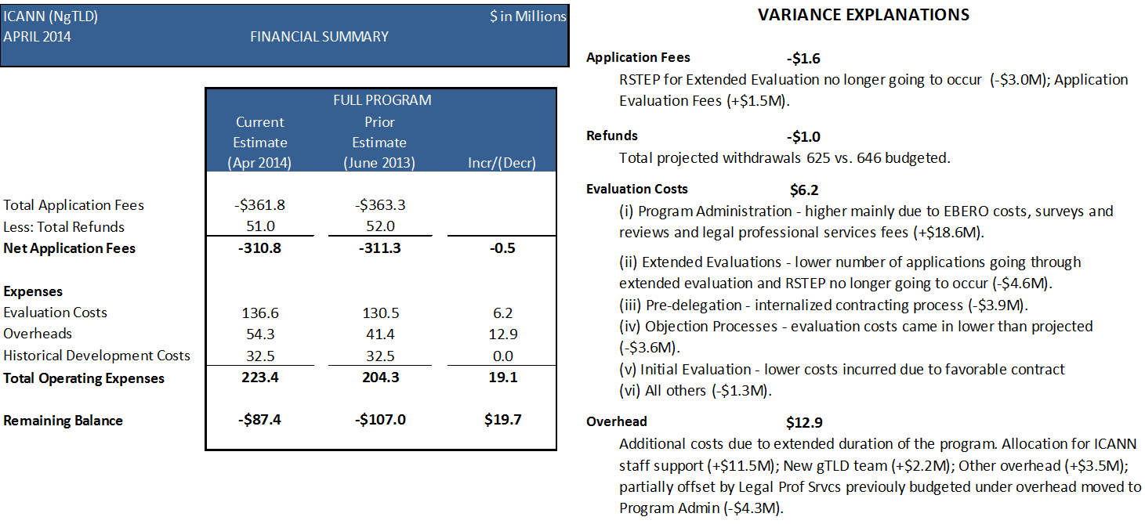

**\*All information is related to the current round of the New gTLD Program (2012-2017)**

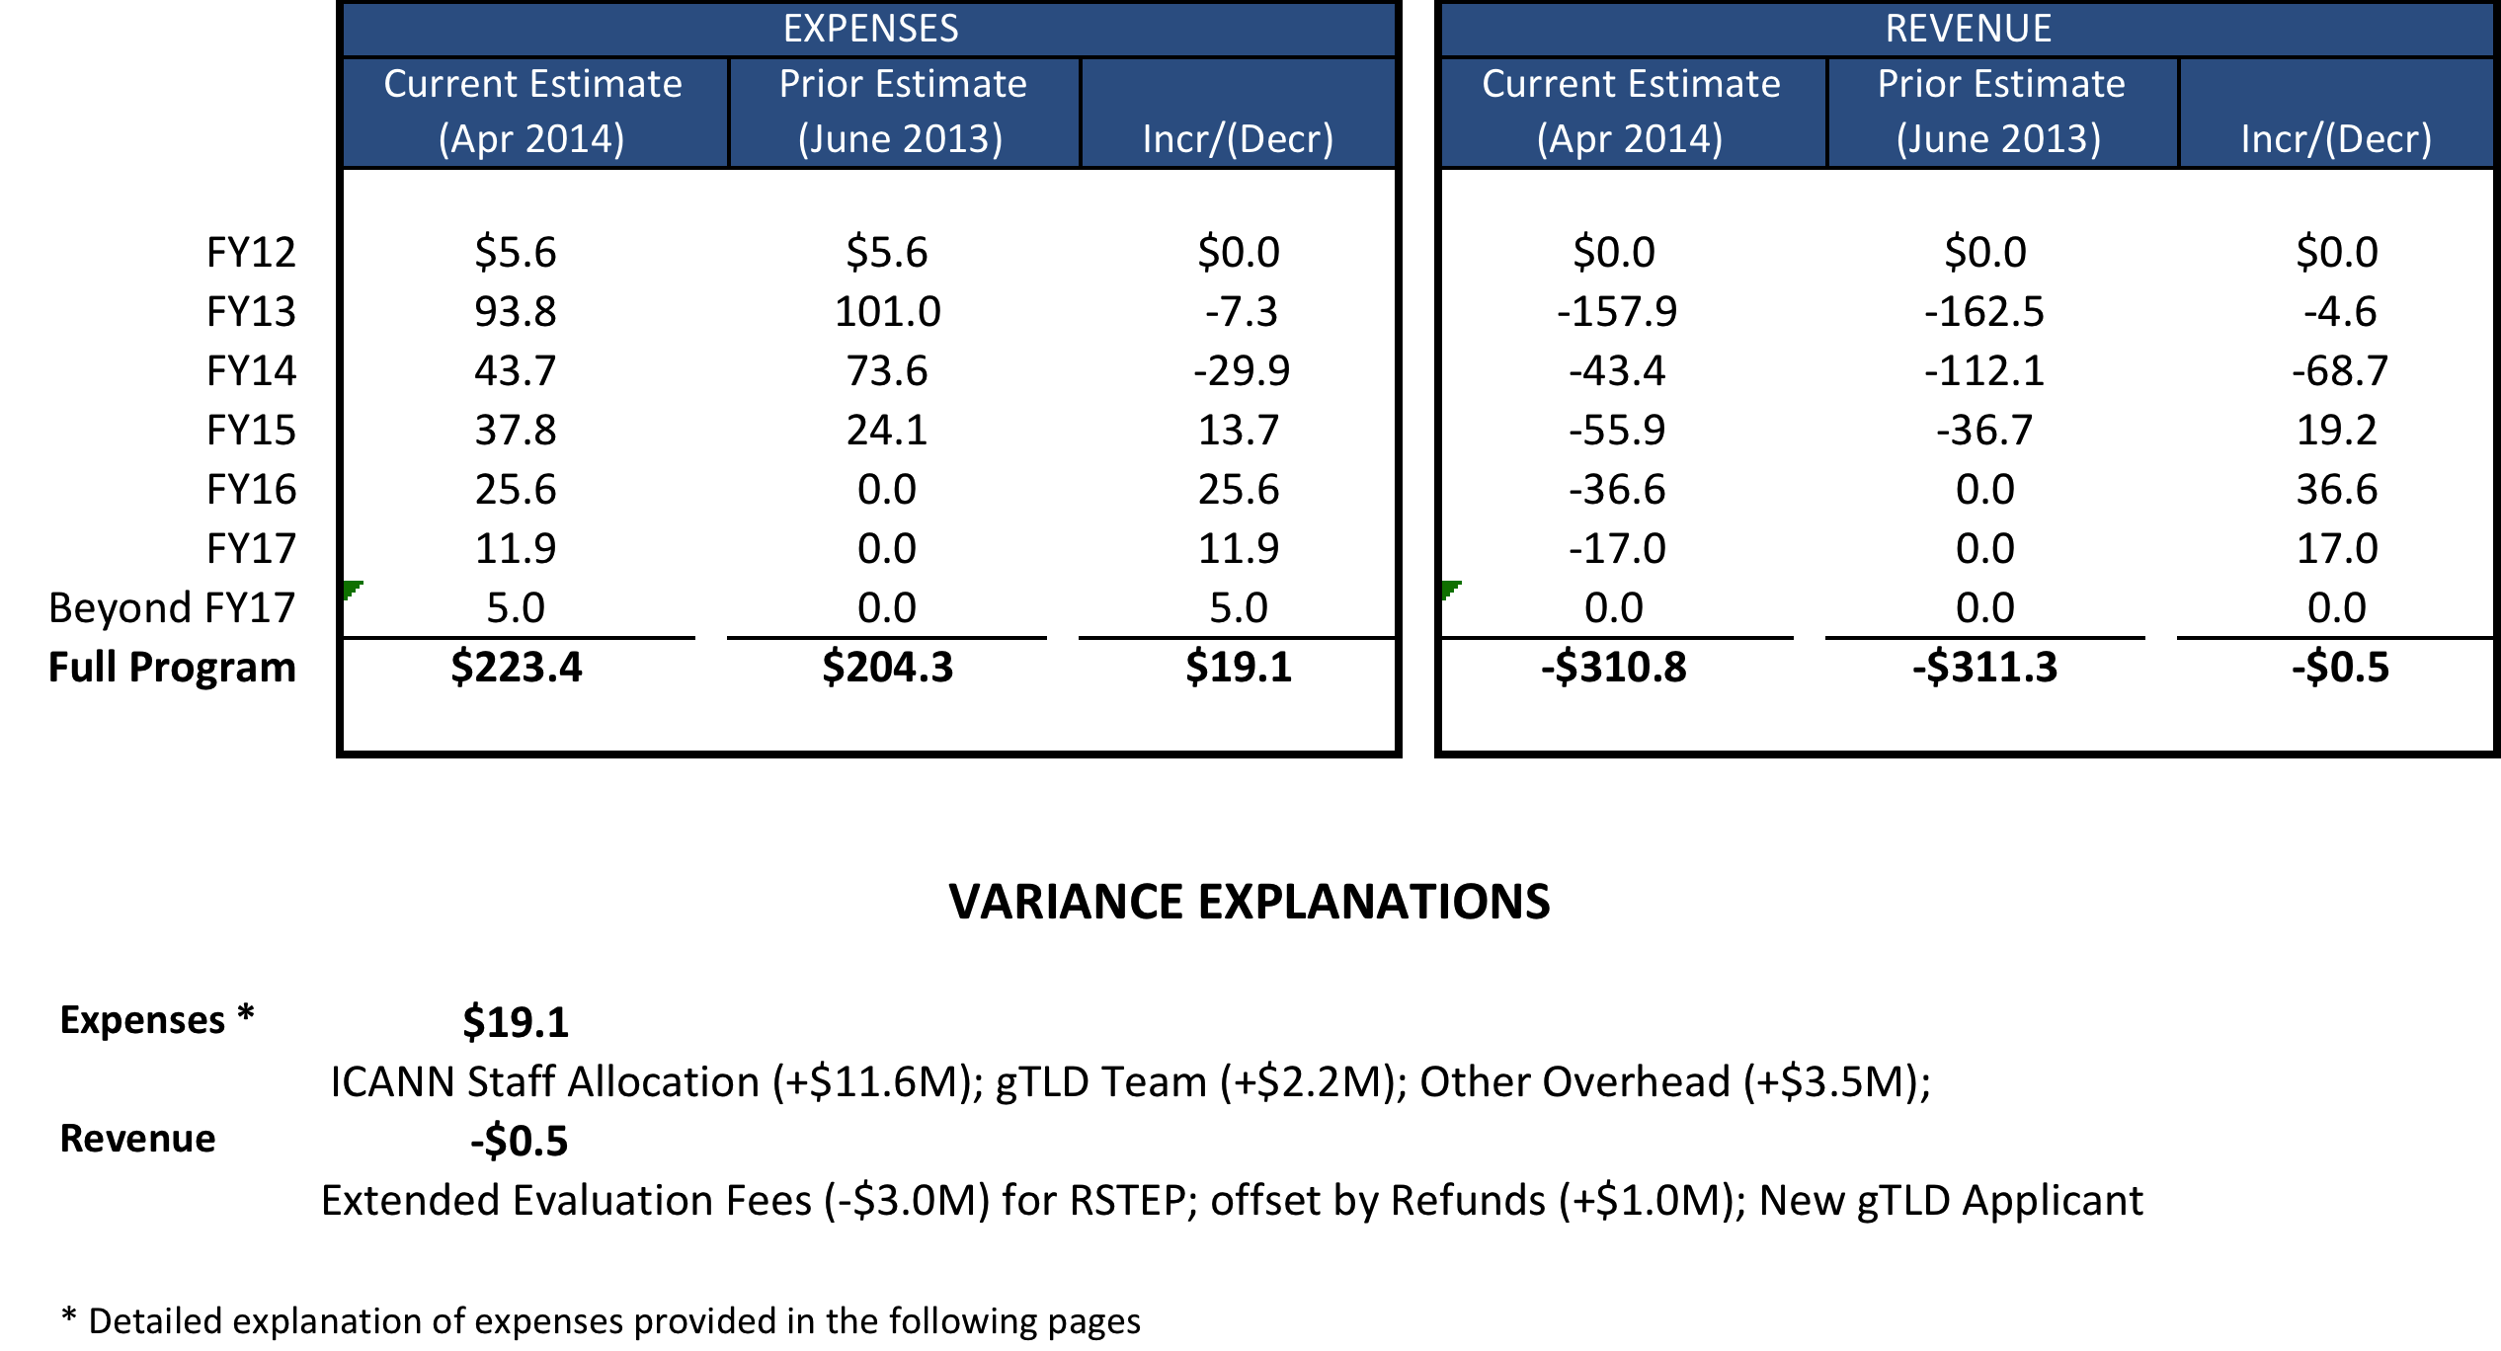

**3.2. New gTLD Program* Multi-year View**

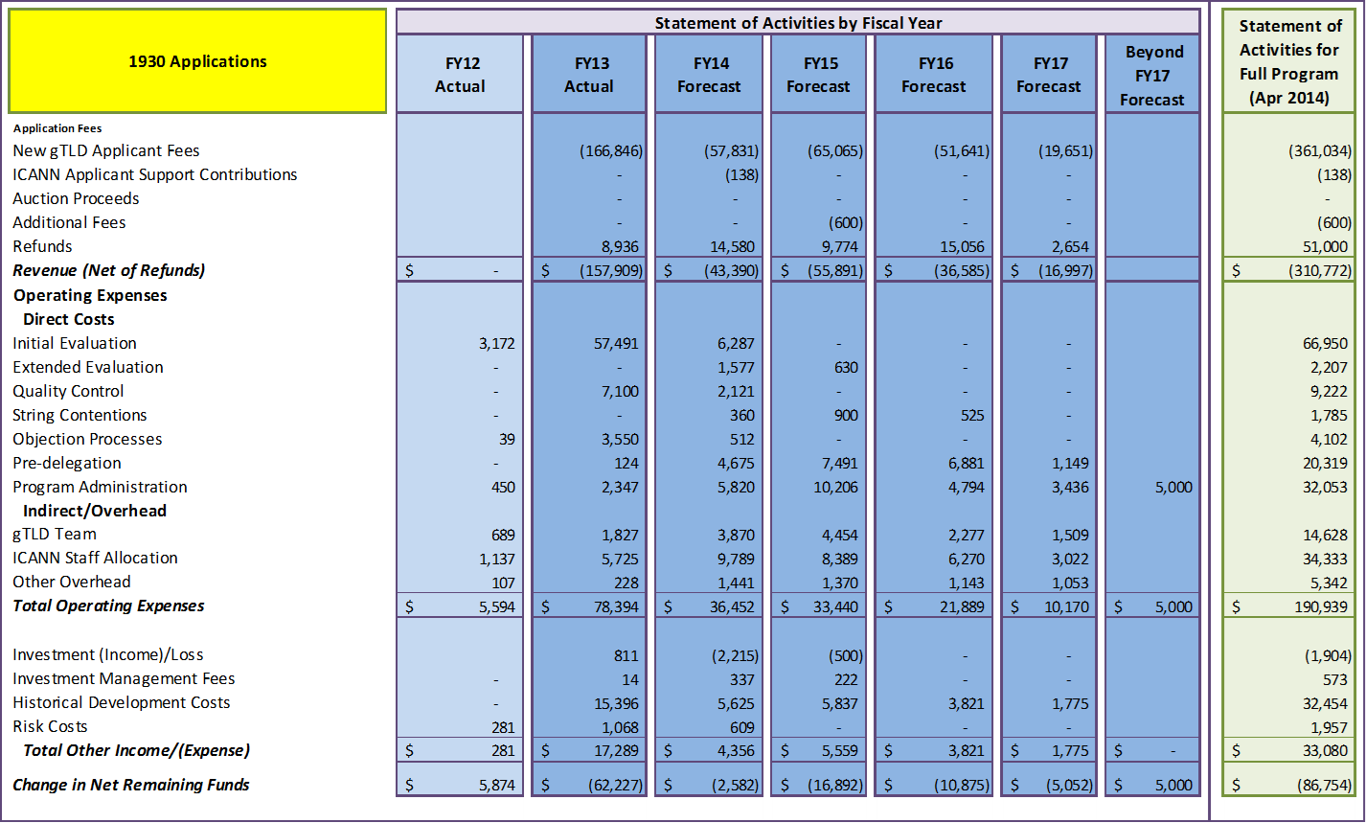

**\*All information is related to the current round of the New gTLD Program (2012-2017)**

**3.3. New gTLD Program* – Revenue Variance Analysis**

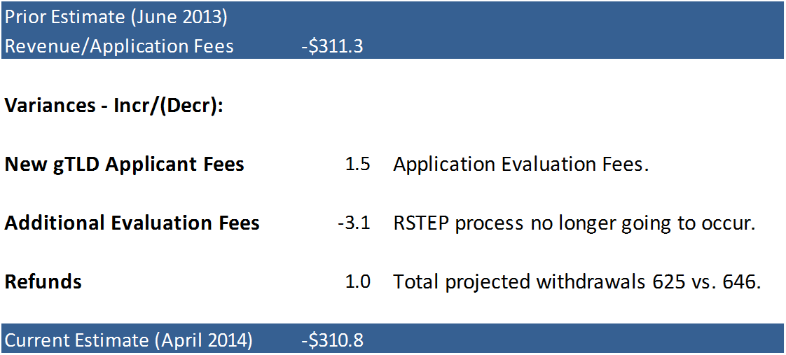

**\*All information is related to the current round of the New gTLD Program (2012-2017)**

**3.4. New gTLD Program* – Operating Expenses Variance Analysis**

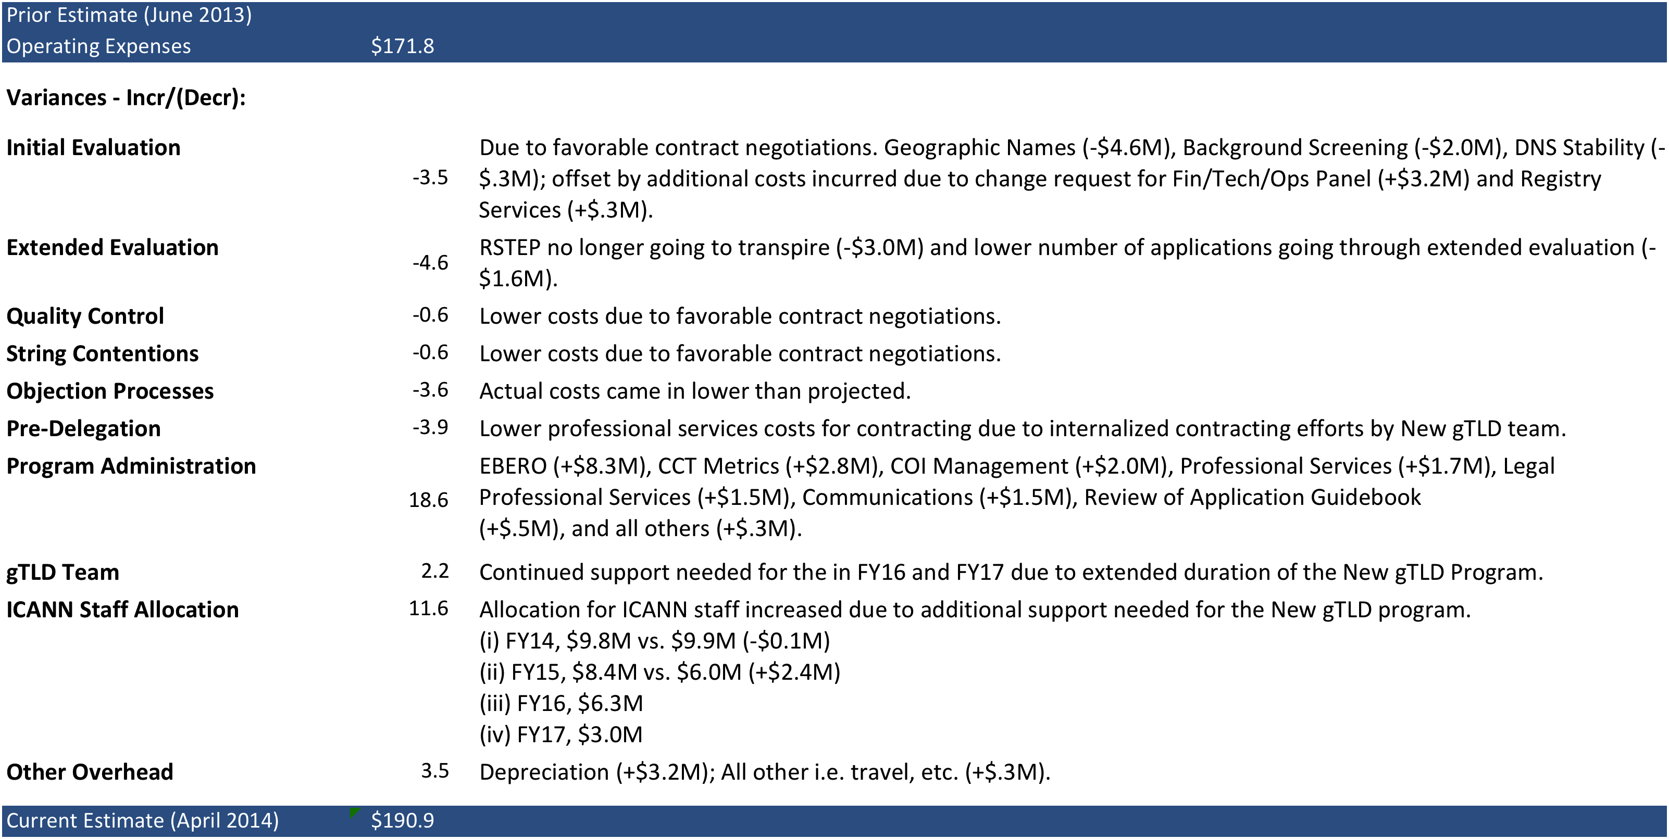

**\*All information is related to the current round of the New gTLD Program (2012-2017)**

Appendix

**A.1: FY15 Draft Budget by Portfolio and Cost Category**



**\* includes depreciation, bad debt, contingency, and allocations to New gtld program**



**A.2: Selected FY15 Projects by Portfolio**





(continued from previous page)







**A.3: FY15 SO/ AC Additional Budget Requests**

The estimated impact of FY15 SO/ AC Additional Budget Requests is approximately $680K ($671k in FY14). Certain requests were not granted because they are funded in the draft budget submitted by Staff. Below are summaries of the requests by SO/AC group and type of request followed by a detailed list of the requests. The requests can also be found in .xls and .pdf formats on ICANN.org.















